Vendor Services & Contributions Form
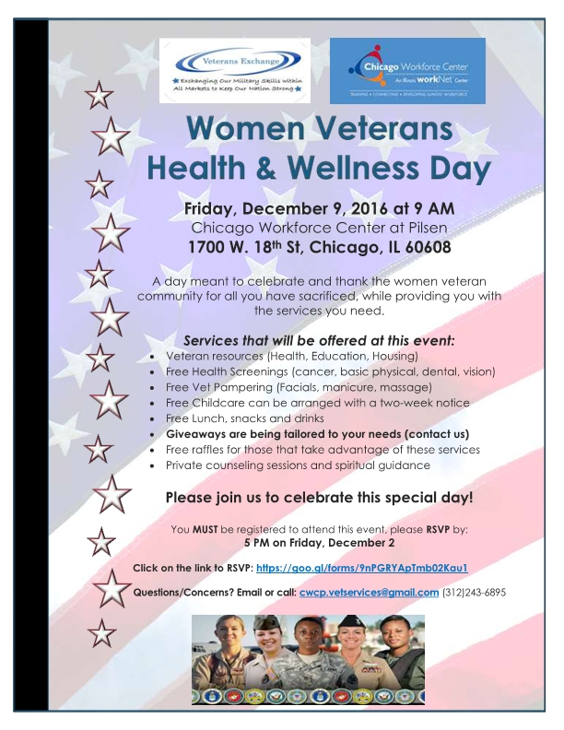
This form will help us get a visual on the type of contributions / services you would like to sponsor for our Veteran Women's Health and Wellness Day. The event will be held at the Instituto del Progreso Latino located at 2520 S. Western Ave., Chicago IL 60608
Event Flyer

Veteran Women Wish List

Company / Organization Name

Industry (please choose the option that best describes you)
Business / Employer
Private / Individual Donor
Community / Social Service
Medical Services (Vision, Dental are included)
Other

Contact Person

Address (please include city, state, zip)

Email

Phone Number

Services
Please answer the following questions. If this does not apply or are not interested in contributing in this area, please select 'N/A or none of these" for all the questions in this section.
What services would you like to sponsor?
Counseling (family, individual)
Spiritual Guidance (family, individual)
Veteran resources information / assistance (housing, utility bill payment, Child Care assistance, education, employment/training information, health vet benefits, etc.)
Medical screening (vision and dental included)
Other
What specific service would you like to present?

If "Medical Screening" was selected, what specific screening would you like to provide? (check all that apply)?
 | Vision (exam)
 | Dental (exam / cleaning)
 | Blood Pressure / Testing
 | Cancer screening
 | Please specify:
Do you need a parking permit for your trailer? |  |  | Yes |  | No
Do you need additional / other accommodations? |  |  | Yes |  | No

What accommodations do you need, to present your services?
 | How many persons from your organization are coming? Total: |  |  |  | Persons
 | Computers for online application? How many electricity outlets required?
 | Cubicle / closed area for a more private discussion
 | Size of private room required? Approx. s.f. |  | How many rooms required?
 | Extra Table What size? How many?
 | Chairs How many?
 | Garbage Bin How many?
 | Space for a standing banner
 | Other

Donations
Please answer the following question. If this does not apply or are not interested in contributing in this area, please select N/A or None of these" for all the questions in this section.
What type of donations would you like to contribute? (check all that apply)
Food
Beverages
Food Serving Stencils
Giveaways
Raffle Items
Veteran Wish List (tailored to veteran’s selection)
Papering Services
Other

If “Giveaways” was selected, please choose the items yo would like to sponsor? (check all that apply)
Hygiene Items (oral care items, shampoo/conditioner, body wash, tampons/pads, razors, comb/brush, etc.)
Wellness products (Vitamin samples, nutrition samples, weight loss product samples, etc.)
Office / School Supplies (backpacks, pens, pencils, flash drives, sticky notes, notepads, calculators, etc.)
Clothing (coats, scarfs, gloves, business attire, shoes, sox, t-shirts, underwear, small blankets/towels, etc.)
CTA Bus Passes
Super Market Gift card (for holiday meal)
Other

If “Raffle Items” was selected, please choose the items you would like to sponsor? (check all that apply)
Laptop / Tablet / Smartphone
Gift Cards (retail, gas, money card)
Beauty Product (facial kit, cosmetics, perfume, etc.)
Accessories (hand bag, jewelry, etc.)
Other

If “Pampering Services” was selected, please choose the items yo would like to sponsor? (check all that apply)
Facial + 2 facial products for veteran to take home
Massage
Manicure
Other

