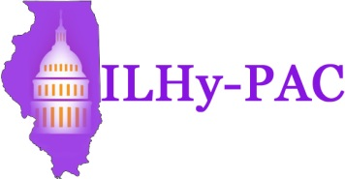

Illinois Hygiene Political Action Committee
Registration Form for 5th Annual Fundraiser
November 2, 2018
At
Effing Brewing Company
Effingham, IL

Name________________________________________________Date_______________

Address_________________________________________________________________

City__________________________________ State__________ Zip________________

Phone______________________________ E-Mail______________________________

Employer________________________________________________________________

Occupation______________________________________________________________

Do you have any contracts with the State? YES_____________ NO_______________

My registration fee to the ILHy-PAC fundraiser:

My $50 is enclosed. Check #________________
Student: $25 enclosed. Check#_________________

Contributions or gifts to ILHy-PAC are not deductible as charitable contributions for federal income tax purposes.

Contributions to the ILHy-PAC may be used to support candidates for local or state office. These contributions are voluntary and not required as a condition of membership.

Please make checks payable and remit to:

ILHy-PAC
Send to:
Becky Bunge, RDH
1195 Banbury Circle
Naperville, IL 60540
630-886-3327

